Weather Data Analysis Report

Project Overview:

This project analyzes a weather dataset using Python. The dataset was cleaned, explored, and visualized to understand weather conditions such as temperature and humidity across different locations.

Objectives:
- Load the weather dataset.
- Clean the data.
- Analyze weather information.
- Create charts for better understanding.
- Find useful insights from the data.

Dataset Information:
- Dataset: Weather Data
- Records: 1,000,000
- Columns: 6
Columns:
- Location
- Date
- Temperature
- Humidity
- Precipitation
- WindSpeed

Data Cleaning:
The following steps were performed:
- Loaded the dataset using Pandas.
- Renamed column names.
- Converted the Date column to datetime format.
- Checked for missing values.
- Removed duplicate records.

Data Analysis:
The following analyses were completed:
- Highest Temperature by Location
- Highest Humidity by Location
- Temperature Distribution
- Average Temperature
- Average Humidity

Visualizations:
Chart 1: Highest Temperature by Location
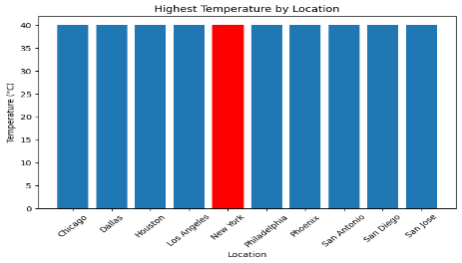
- All locations recorded a highest temperature close to 40°C.
- There is very little difference in maximum temperatures between locations.
Chart 2: Highest Humidity by Location
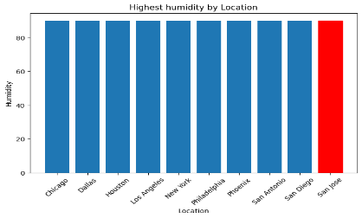
- All locations reached a maximum humidity of around 90%.
- Humidity levels are similar across all cities.

Chart 3: Temperature Distribution
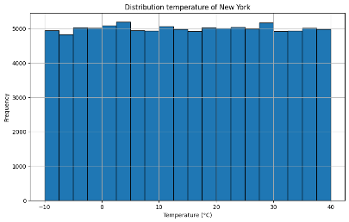
- Temperature values range from -10°C to 40°C
- The data covers both cold and hot weather conditions
- No major outliers are visible

Key Findings:
- Maximum temperature is around 40°C.
- The dataset contains 1 million weather records.
- Maximum humidity is around 90%.
- The weather data is clean and suitable for analysis.
- Charts help compare weather conditions across different locations

Conclusion:
This project successfully demonstrates the complete data analysis process using Python. The dataset was cleaned, analyzed, and visualized to understand weather patterns. The analysis shows similar maximum temperature and humidity values across all locations

